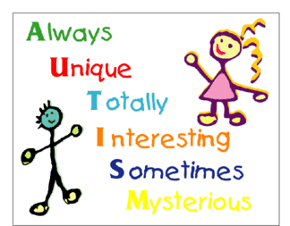
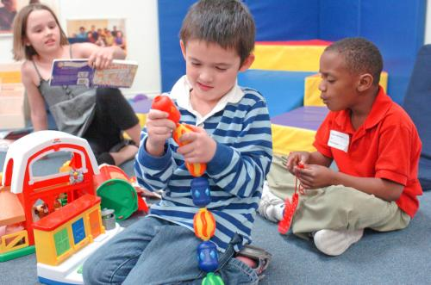
+

Table of Contents:

Warning Signs ………………………………….. pg. 2
What is Autism …………………………………… pg. 3
Assessment ………………………………………………. pg. 4
Interventions……………………………………… pg. 5
Treatment…………………………………………… Pg. 6
National and Local Resources…………………… Pg. 7

What you need to know about:
Autism
Spectrum Disorders

By Christina Saad, Penny Rogers, Tram Nguyen, and Jennifer Lausier


Warning Signs of Autism
If your child is two months old, you should consider talking to your doctor if your child exhibits the following behavior:
• Doesn’t respond to loud sounds
• Doesn’t watch things as they move
• Doesn’t smile at people
• Doesn’t bring his/her hands to mouth
• Can’t hold his/her head up when pushing up on tummy
If your child is four months old, you should consider talking to your doctor if your child exhibits the following behavior:
• Doesn’t watch things as they move
• Doesn’t smile at people
• Can’t hold his/her head steady
• Doesn’t make sounds or coo
• Doesn’t bring things to his/her mouth
If your child is six months old, you should consider talking to your doctor if your child exhibits the following behavior:
• Doesn’t reach for things
• Show no affection for caregivers
• Doesn’t respond to sounds around her/him
• Doesn’t make vowel sounds (eh, ah, oh)
• Doesn’t laugh or squeal
• Seems unusually stiff or unusually floppy
If your child is nine months old, you should consider talking to your doctor if your child exhibits the following behavior:
• Doesn’t look where you point
• Doesn’t respond to his/her own name
• Doesn’t babble (mama, dada)
• Doesn’t play back and forth type games
• Doesn’t seem to recognize familiar people
• Doesn’t have at least six words
• Doesn’t gain new words
• Doesn’t notice or react when a caregiver leaves or returns
• Doesn’t walk
• Loses skills he/she once had
If your child is 2 years, you should consider talking to your doctor if your child exhibits the following behavior:
• Doesn’t use 2-word phrases (mama up, want milk)
• Doesn’t know what familiar things (cup, spoon, phone) are used for
• Doesn’t imitate actions and words
• Doesn’t follow simple instructions
• Doesn’t walk steadily
• Loses skills he/she once had
• Is unusually withdrawn and not active in social situations
• Is easily distracted and has trouble focusing on an activity
If your child is 3 years old, you should consider talking to your doctor if your child exhibits the following behavior:
• Has unclear speech or drools a lot
• Doesn’t speak in sentences
• Doesn’t follow simple instructions
• Can’t work simple toys (simple puzzles, turning knobs/handles, peg board)
• Shows little interest in toys
• Doesn’t want to play with other children
• Doesn’t play make believe or pretend
• Doesn’t make eye contact
• Falls down often or has trouble on stairs
• Loses skills he/she once had
If your child is 4 years old, you should consider talking to your doctor if your child exhibits the following behavior:
• Ignores other children
• Doesn’t respond to people outside the family
• Shows no interest in make believe or pretending games
• Can’t retell a favorite story
• Doesn’t follow 3-step directions
• Doesn’t use “you” and “me” correctly
• Doesn’t understand “same” and “different”
• Speaks unclearly
• Doesn’t scribble or has trouble scribbling with a crayon
• Loses skills he/she once had
If your child is 5 years old, you should consider talking to your
doctor if your child exhibits the following behavior:
• Doesn’t show a wide range of emotions
• Shows behavioral extremes (unusually aggressive, fearful, sad, shy)
• Is unusually withdrawn and not active in social situations
• Is easily distracted and has trouble focusing on an activity for
more than five minutes
• Doesn’t respond to people or responds only superficially
• Can’t tell the difference between real and make believe
• Doesn’t participate in a wide variety of games and activities
• Can’t give his/her first and last name
• Doesn’t use plurals, pronouns or past tense properly
• Doesn’t talk about daily activities
• Doesn’t draw pictures
Loses skills he/she once had
http://autismsciencefoundation.org/autism-warning-signs

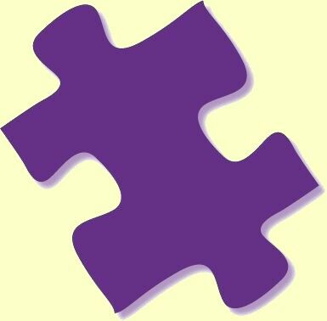
What is Autism?
Autistic Disorder is usually characterized as “classic autism”- it is marked by abnormal or impaired development in social interaction, most markedly lack of language skills. The child may also display a restricted repertoire of activity and interests.
Asperger’s Disorder includes children that also have impaired social development, with restrictive patterns of behavior, interests or activities. However they do not have delays in communication.

PDD-NOS (Pervasive Developmental Disorder)- is designed for the child that may display some of the above listed symptoms but does not have enough of the symptoms to qualify for either, Asperger’s or Autism.

Childhood Disintegrative Disorder- children develop normally through 3 or 4. Then over a few months, children lose language, motor, social, and other skills that they already learned. Prognosis is poor, by age 10 most children with this disorder have the same symptoms as children with severe autism.
- A child who is affected loses:
  - Communication Skills
  - Nonverbal behaviors
  - Skills they had already learned

Rett’s Disorder- is currently classified within the Spectrum disorders however research has linked the disorder to a specific gene. Rett’s is caused by mutations on the X chromosome on a gene called MECP2. The disorder primarily affects females, and causes problems in brain function that are responsible for cognitive, sensory, emotional, motor and autonomic function. These can include learning, speech sensory sensations, mood movement, breathing, cardiac function, and even chewing, swallowing, and digestion. Symptoms appear after an early period of apparently normal or near normal development until six to eighteen months of life, when there is a slowing down or stagnation of skills. A period of regression then follows when she loses communication skills and purposeful use of her hands.

Statistics regarding Autism and Asperger’s:
- Prognosis varies depending on the timing and quality of intervention
- Still, only 2.59% of children under age three are being served through the federally-funded Early Intervention program, which is designed to mitigate developmental delays and disorders
- Scientific studies have demonstrated that early intensive behavioral intervention improves learning, communication and social skills in young children with autism
- According to the Centers for Disease Control, the incidence rate for autism spectrum disorders is now as high as 1 in 110, including 1 in 70 boys.

Assessment:

The following screenings are helpful when assessing for Autism:
- Lead Screening
- Audiological evaluations
- Behavioral Screenings
Checklist for parents and/or teachers
- A comprehensive assessment for Autism requires multiple methods employed across multiple settings by a multidisciplinary team

A medical screening should include:
Developmental Milestones
  - Specifically language and social developmental milestones
  - Any developmental regression
Medical History
  - Current and Hearing Screenings
  - Chronic ear infections
  - Immune dysfunction
  - Autoimmune disorders
  - Allergy history
  - Gastrointestinal symptoms
Family History
  - Family History of any autism spectrum disorder would support an autism diagnosis


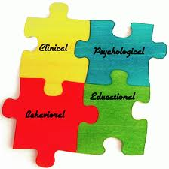
Indirect Assessment:
- Data from caregivers and teachers
- Rating Scales
- Parent/Child Interview
Direct Assessment:
- Direct observation
- Psycho-educational assessment (school age children)

Rating Scales that may be used by parents and clinicians:
- Gilliam Autism Rating Scale-Second Edition (GARS-2)
- Asperger Syndrome Diagnostic Scale (ASDS)
- Pervasive Developmental Disorders Screening Test-II (PDDST-II)
- Checklist for Autism in Toddlers (CHAT) and M-CHAT
- Pervasive Developmental Disorders Screening Test-II (PDDST-II)
- The High Functioning Autism Spectrum Screening Questionnaire (ASSQ)

Interventions/Strategies:
Early Intervention has been proven successful based on the following reasons:
- Early Intervention leads to better outcomes.
- Intervention programs should be intensive, specifically during the preschool years. A minimum of 25 hours per week, 12 months per year of systemically planned educational activity and developmentally appropriate educational activity toward identified objectives. These objectives should be observable, measurable behaviors and skills that affect a child’s participation in the educational setting, the community, and family life.
- Intervention must involve families in the development of priorities, goals, and treatment plans and must include family training, support, and consultation.
- Interventions must be individualized to the specific needs, strengths, and interests of each child.

Strategies for parents working with children diagnosed with ASD:
- Communication:
  - Check for understanding
  - Provide training on nonverbal communication skills
  - Provide direct instruction in multiple meaning words
  - Provide training on how to begin, end and maintain conversations
- Social Skills:
  - Guard the child from bullying or teasing
  - Involve the child in a social skills group
  - In school, provide direct social skill instruction focusing on areas such as reading and responding to social cues
  - Use visual reminders to prompt social skills
  - Realize that the child may have had more than enough social interaction during the day and may need a place to be alone
- Behavioral support strategies at home and school:
  - Provide a predictable and safe environment
  - Limit opportunities for obsessive talk about special interests
  - When trying to change inappropriate behavior teach appropriate alternatives
  - Use humor to diffuse tension
  - Teach anger control
  - Teach cause and effect
  - Provide a safe haven for the child when they need to be alone
- Academic strategies:
  - Capitalize on children’s exceptional memories and provide them opportunities to showcase their knowledge
  - Provide visual schedules for the day/week
  - Consult parents when designing the academic program
  - Regularly check for understanding
  - Parents should inform teachers about the child’s obsessive area of interest so it can be linked to other subjects
  - If writing is difficult, writing projects should be modified
  - Accommodations for state or district tests
  - If need accommodations through an Individualized Education Plan (IEP) or Section 504 Accommodations should be discussed or implemented

Treatment:

+
Preschool:
- Programs that emphases a range of strategies based intense structured approaches or discrete trial training, self-management, prompt fading, and modeling
These types of programs include:
- ABA
- Pivotal response training (PRT)
- Incidental teaching methods
- Developmental-pragmatic approaches
- The TEACCH program
School Age:
- Visual schedules, written rules and directions, reduced workload, access to assistive technology within the classroom such as computer keyboards, and computerized
- A range of strategies based on ABA communication devices

Psychopharmacologic Interventions:
Neuroleptics
- Treat symptoms of aggression, self-injurious behaviors, hyperactivity, stereotypes, social withdrawal, and sleep disturbances.
Antidepressants
- Treat mood disorders such as depression and anxiety. Decrease repetitive behaviors, less aggression and maladaptive behaviors in children.
Psycho stimulants
- Treat ADHD symptoms in children with autism.
Alpha-adrenergic agonists
- Treat children with ADHD and hyper arousal, although there is limited evidence of their effectiveness in children with autism.

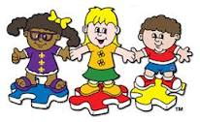

Service providers can be:

Special education teachers/aides

Speech Therapists

Behavioral Therapists

Occupational therapists

Physical therapists

Counselors/Psychologists

+
Local Sacramento Area Resources:

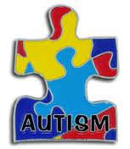
Autism Treatment Providers in Greater Sacramento
Applied Behavioral Consultants (916) 364-7800
Behavioral Education for Children with Autism (916) 444-2784
B.E.S.T. Consulting (916) 448-2050
Captiol Autism Services (916) 923-1789
Center for Autism and Related Disorders (916) 374-0800
Central Valley Autism Project (916) 521-4791
Lovaas Institute (916) 979-9398
Teaching Autistic Children (916) 729-3098
Therapeutic Pathways (916) 489-1376

- Alta California Regional Center
  - http://www.altaregional.org/
- UC Davis Mind Institute
  - http://www.ucdmc.ucdavis.edu/mindinstitute/
- Autism Speaks Inc. Autism Speaks and Autism Speaks It's Time to Listen & Design are trademarks owned by Autism Speaks Inc.
  - http://www.autismspeaks.org/what-autism/treatment
- Autism Society | 4340 East-West Hwy, Suite 350 | Bethesda, Maryland 20814 | 1(800) 328-8476
  - http://www.autism-society.org

[Street Address]
[City], [State][Postal Code]
[Web Address]
References
- Alta California Regional Center. (2008). Autism spectrum disorder. Retrieved from http://www.altaregional.org/whoWeServe/autism/
- Autism Society of America. (2012). About autism. Retrieved from http://www.autism-society.org/about-autism/
- Autism Speaks Inc. (2012). What is autism?. Retrieved from http://www.autismspeaks.org/what-autism
- Barnhill, G. (2010). Asperger syndrome: A guide for parents and educators. In A. Canter, L. Paige & S. Shaw (Eds.), Helping children at home and school III: Handouts for families and educators (p. S8H6). Bethesda, MD: National Association of School Psychologists.
- Barnhill, G. (2010). Asperger syndrome: Social skills interventions. In A. Canter, L. Paige & S. Shaw (Eds.), Helping children at home and school III: Handouts for families and educators (p. S8H7). Bethesda, MD: National Association of School Psychologists.
- Frost, L., & Bondy, A. (1994). The picture exchange communication system training manual. Cherry Hill, NJ: PECS, Inc.
- Gray, C., & White, A. L. (2002). My social stories book. Gateshead, Great Britain: Arthenaeum Press
- Myles, B. S., & Adreon, D. (2001). Asperger syndrome and adolescence: Practical solutions for school success. Shawnee Mission, KS: AAPC.
- Myles, B. S., Cook, K. T., Miller, N. E., Rinner, L., & Robbins, L. A. (2000). Asperger syndrome and sensory issues: Practical solutions for making sense of the world. Shawnee Mission, KS: AAPC.
- Myles, B. S., & Simpson, R. L. (2001, November). Effective practices for students with Asperger syndrome. Focus on Exceptional Children, 34(3), 1-14.
- Reese, R. M., Richnam, D. M., Zarcone, J., & Zarcone, T. (2003). Individualizing functional assessments for children with autism: The contribution of perseverative behavior and sensory disturbances to disruptive behavior. Focus on Autism and Other Developmental Disabilities, 18, 87-92.
- Ruble, L., & Akshoomoff, N. (2010). Autism spectrum disorders: Identification and diagnosis. In A. Canter, L. Paige & S. Shaw (Eds.), Helping children at home and school III: Handouts for families and educators (p. S8H9). Bethesda, MD: National Association of School Psychologists.
- Ruble, L., & Akshoomoff, N. (2010). Autism spectrum disorders: Intervention options for parents and educators. In A. Canter, L. Paige & S. Shaw (Eds.), Helping children at home and school III: Handouts for families and educators (p. S8H10). Bethesda, MD: National Association of School Psychologists.
- UC Davis Mind Institute. (2012). Autism spectrum disorder. Retrieved from http://www.ucdmc.ucdavis.edu/mindinstitute/resources/autism.html

